## Share Price Volatility

## Matt Burns

## Fall 2020

### https://github.com/mattburns963/680.git

**Problem and Hypothesis**

Two key components of many options pricing models include intrinsic value and time value. Intrinsic value is driven by the difference between the strike price and the current market price. The large the difference (i.e. discount to market price) the high the intrinsic value. The time value is driven by a stock’s expected volatility and the amount of time before expiration. The high the volatility, the higher the cost of the option. Due to the impact of volatility on the price of options, it is important for one to have a keen understanding of stocks’ volatility before investing in options.

In an effort to gain a better understanding of volatility, this project investigated stock market data. It focused specifically the prices of companies’ stock shares and how they fluctuate throughout the week. This project explored the volatility of over 100 companies’ share prices throughout the 6 weeks of trading. Specifically, three topics were explored:

1. How did stock’s weekly volatility change with respect to a common volatility index. Other than splitting out the six weeks for this comparison, time was out of scope for this project. This project will not include a prediction of when specific share prices will become more volatile
2. Cluster analyses were completed to identify which shares exhibited similar volatility characteristics over the six-week period. Four potential dividing attributes were explored to facilitate these analyses. This will allow me to understand how I can bucket the stocks into groups that have similar variances.
3. Finally, stocks with similar volatilities were identified using a simple correlation. This provided insight into potential trades that can be made if pricing on these options diverge.

**Data Retrieval Methodology**

The raw data for the project consisted of share prices at 30-minute intervals over the course of 6 weeks for over 100 S&P 500 companies. To accomplish this, I used an API to Alpha_Vantage to obtain the historic price data. The API defaults to 6 weeks of historic data for the free version and requires a one-minute rest after each pull of 5 stocks. To work around this, I wrote code that pauses for 60 seconds between multiple pulls of 5 stocks. There was a lot of cutting a pasting but the data was correctly obtained using this methodology in Python using PyCharm.

There was very little cleaning that needed to be done. The only step I took was to eliminate the extended hours trades from the data set due to low trade volumes and missing data.

Attributes for each company to facilitate the clustering we easily scraped from the web and data to the dataset in Excel. They include:

* Dividend Yield
* Price to Earnings Ratio
* Price to Sales Ratio
* Market Capitalization

**Analysis Methodology**

To explore the stocks’ weekly variance to a common volatility index (VXX), I calculated the coefficient of variance for each stock for all 6 weeks. The data was entered in Tableau to create plots of the coefficient of variance vs the VXX over 6 weeks.

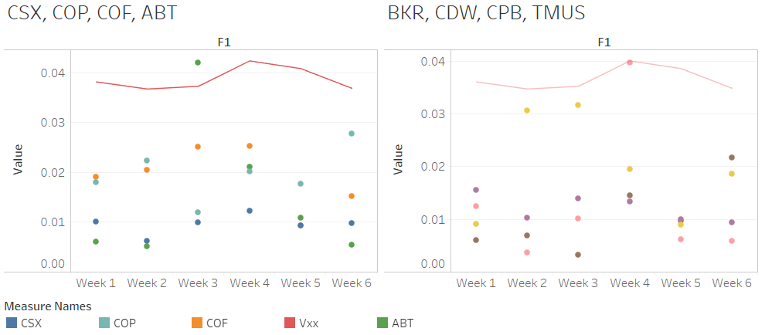

After I calculated the coefficient of variance for each stock for the 6 week period, the cluster analysis was a two-step process.

First, four the coefficient of variance for the stocks was plotted against four candidate attributes. This helped identify which attributes might be worth investigating.

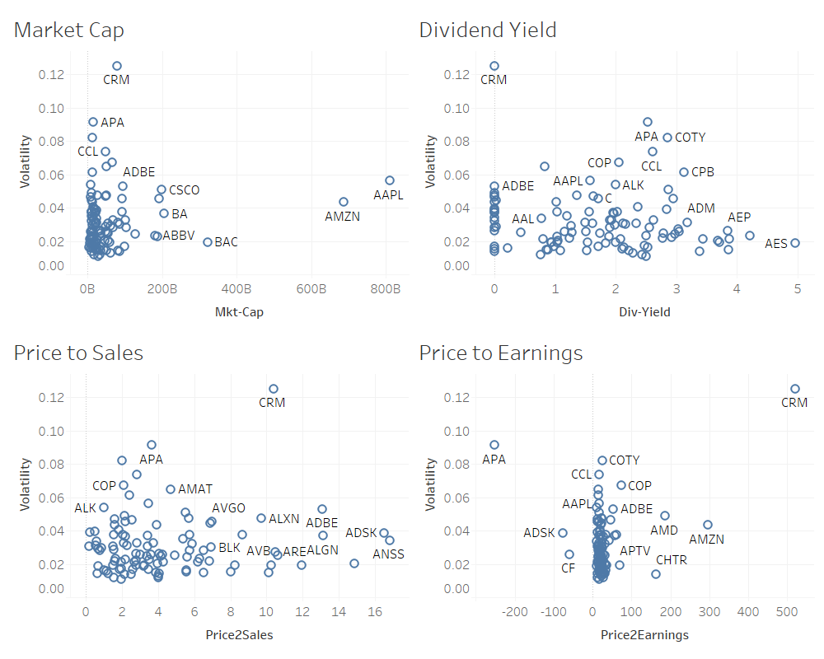

Market Capitalization and Price to Earnings are busts whereas Price to Sales and Dividend are worthy of more rigorous analysis described below.

To run the cluster analyses two steps were taken. The elbow graphs were developed to identify the optimal number of centers. Then the clusters were determined. These were both done in R Studio.

**Cluster by Price to sales ratio**

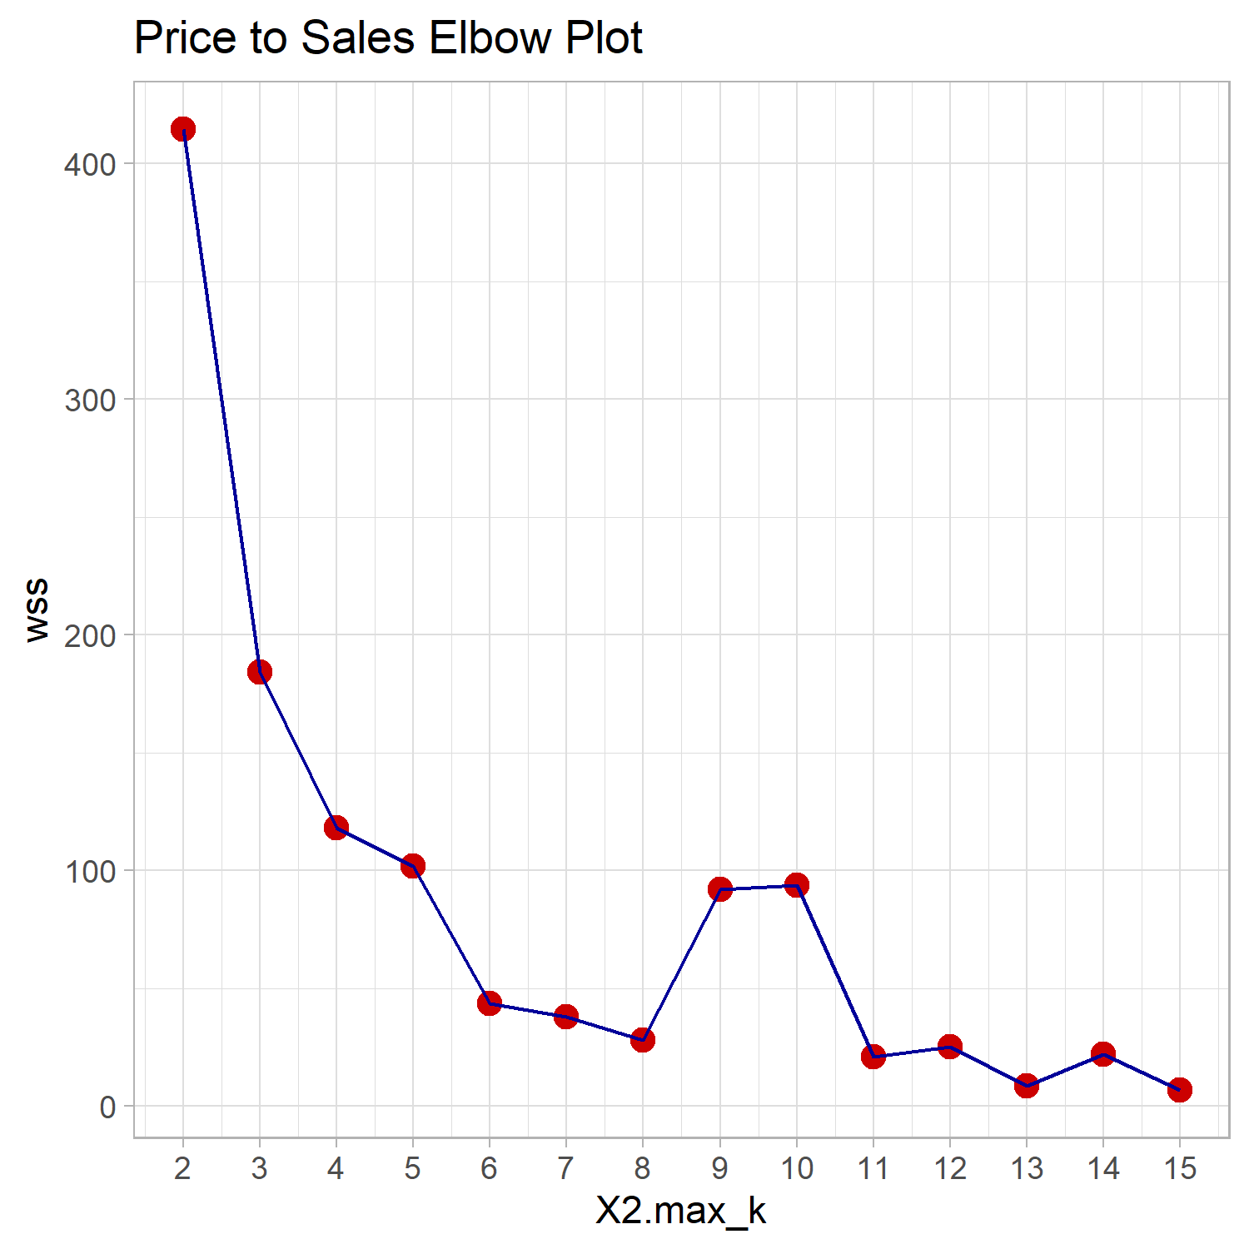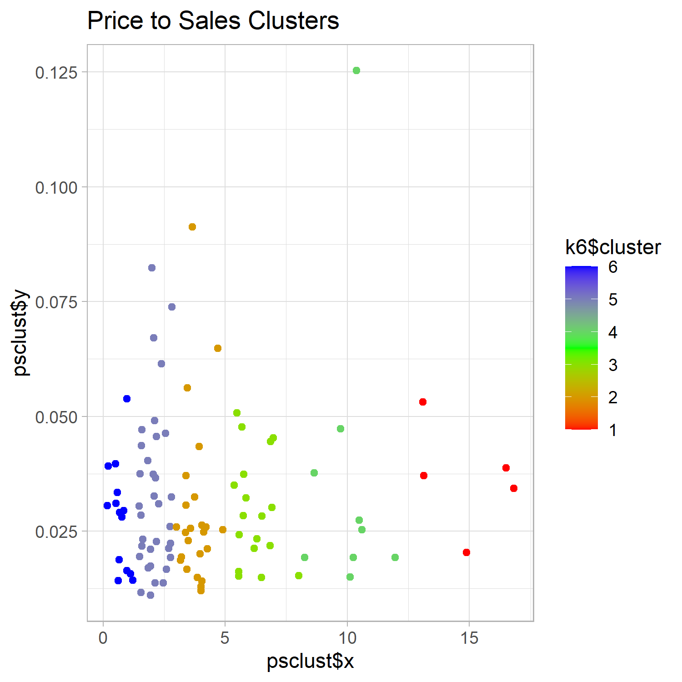

**Cluster by dividend yield**

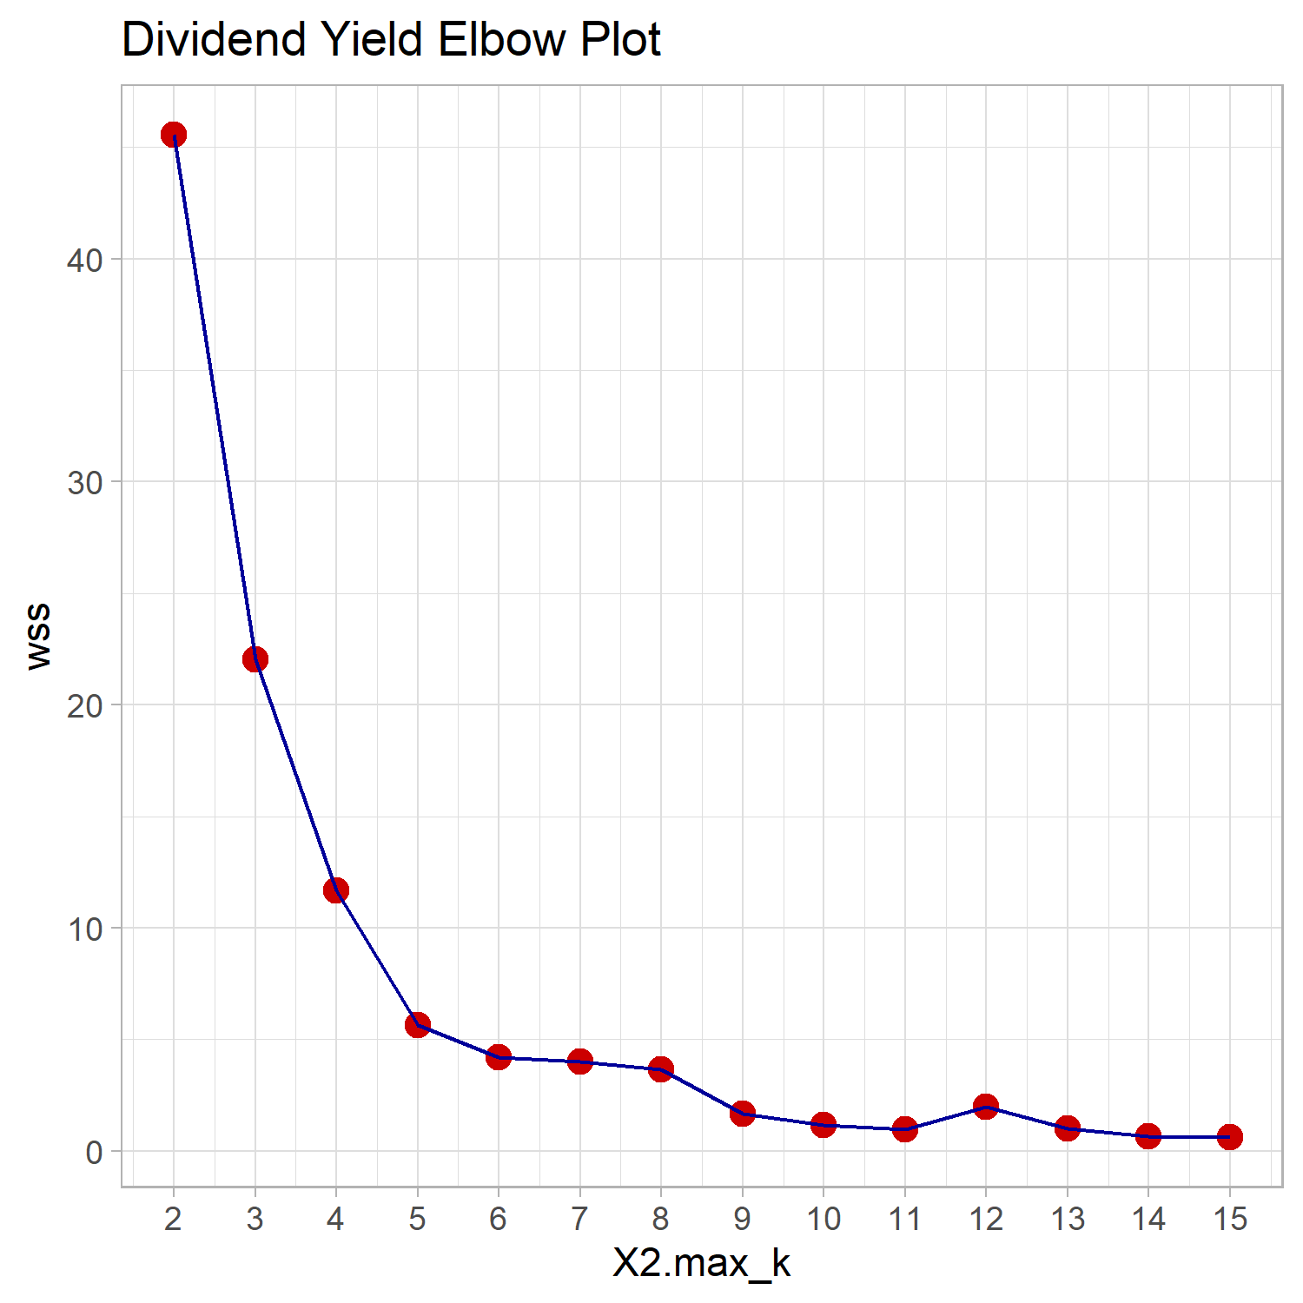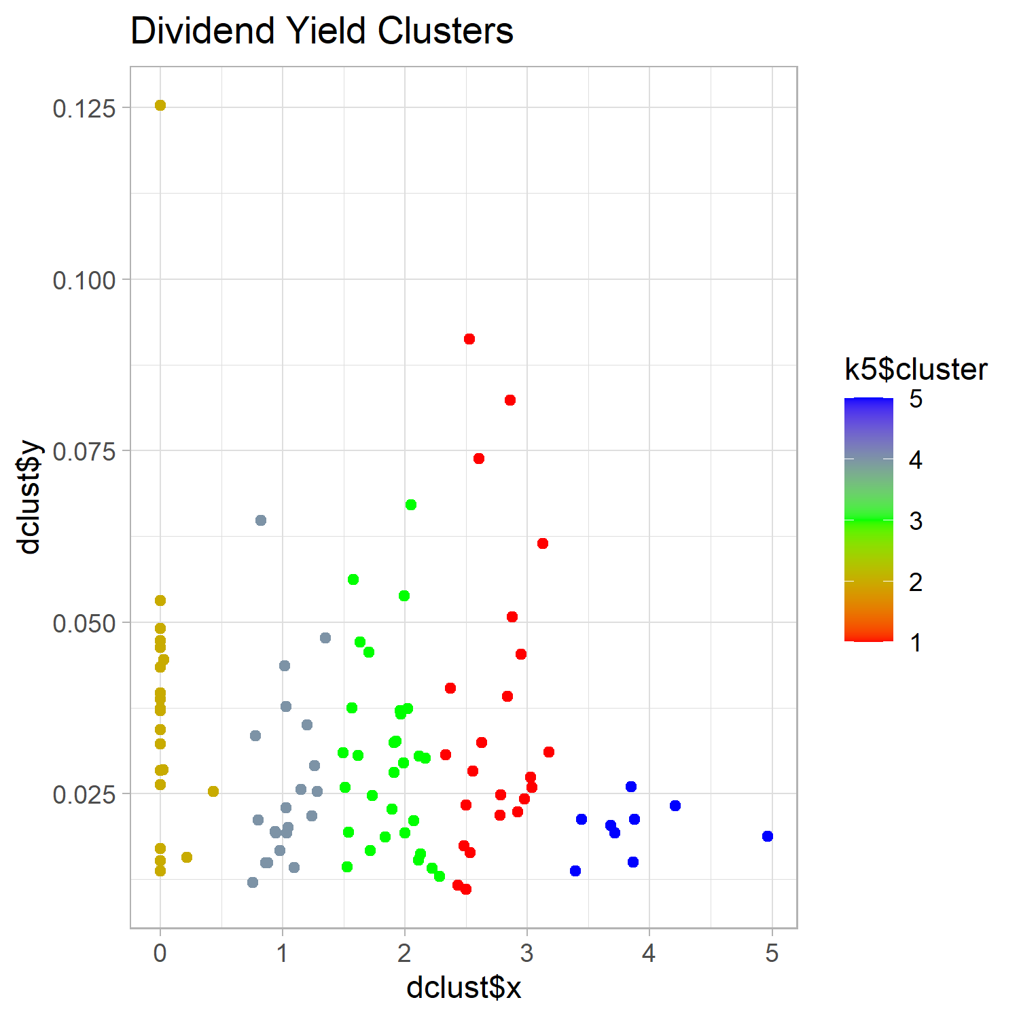

To identify stocks that are have a highly correlated volatility, I calculated the correlation between the stocks. This did not produce any actionable pairs of stocks.

**Conclusions**

1. Stocks’ volatility are not strongly correlated with each other.
2. Few stocks have a correlation with volatility indexes.
3. Clustering by Price-to-Sales ratio and Dividend Ratios is feasible.
4. A handful of stocks are tightly correlated with each other.

**APA references**

Articles regarding share volatility and how to quantify them are below. There are also articles that detail information regarding options and volatility clustering. They provide context, but are beyond the direct scope of this project.

Moffatt, Mike. (2020, August 26). Overview of Volatility Clustering. Retrieved from <https://www.thoughtco.com/volatility-clustering-in-economics-1147328>

This article explains how volatile periods for stock cluster together. It will not be directly used in the analysis, but it does provide insight on various episodes of high volatility.

Boyte-White, Claire. (Updated May 9, 2020). What Is the Best Measure of Stock Price Volatility? Retrieved from

<https://www.investopedia.com/ask/answers/021015/what-best-measure-given-stocks-volatility.asp>

This article explains there we accepted ways of measuring stock volatility. Which are Beta, Maximum Drawdown and Standard Deviation. I will be using a method based on standard deviation in this project, so Maximum Drawdown and Beta will serve as reference points (i.e. sanity checks) for my analysis.

buyupside. (2020). Stock Volatility Calculator. Located at

https://www.buyupside.com/calculators/volatilitycalculatorinput.php

This site calculates the volatility of various stocks. It will be used as a comparison to my calculations.

Kenton, Will. (Updated May 2, 2019). Autoregressive Conditional Heteroskedasticity (ARCH). Retrieved from

https://www.investopedia.com/terms/a/autoregressive-conditional-heteroskedasticity.asp

This article explains a model that is “used to analyze effects left unexplained by econometric models”. The better I understand of the error values from an autoregressive model to better interpret the results of my analysis. I.e. what can be modeled and what cannot.

Chappelow, Jim. (Updated Sep 30, 2019) Generalized AutoRegressive Conditional Heteroskedasticity (GARCH). Retrieved from

https://www.investopedia.com/terms/g/garch.asp

This article explains how the error terms from an autocorrelated model can be autocorrelated themselves. As explained above, the better I understand of the error values from an autoregressive model to better interpret the results of my analysis.

Corporate Finance Institute. (Downloaded Sep, 5, 2020) What is Volatility? Retrieved from

https://corporatefinanceinstitute.com/resources/knowledge/trading-investing/volatility-vol/

This provides a very basic calculation and explanation of volatility. I used it as background information and their calculations can be use on a much richer data set. I.e. intraday prices, not closing prices.

Rothbort, Scott. (Mar 12, 2007). Understanding the Four Measures of Volatility. Retrieved from

https://www.thestreet.com/investing/understanding-the-four-measures-of-volatility-10343098

This article explains the difference between implied volatility and historic volatility. I will be analyzing historic volatility, whereas implied volatility is import in options pricing.

Wiley. (Downloaded Sep. 5, 2020) How to Measure Trading Price Volatility? Retrieved from

https://www.dummies.com/personal-finance/investing/technical-analysis/how-to-measure-trading-price-volatility/

The value add from this article is Disorderly volatility. Trading strategies can be built to take advantage of that kind of volatility and I will use article as context as I strive to identify stock exhibiting that type of volatility.

Ganti, Akhilesh (Updated Jul 14, 2020). Implied Volatility – IV. Retrieved from

https://www.investopedia.com/terms/i/iv.asp

More info regrading implied volatility.

Hayes, Adam. (Updated Aug. 8th, 2020). Stochastic Volatility. Retrieved from

https://www.investopedia.com/terms/s/stochastic-volatility.asp

This describes Stochastic Volatility which varies over time. It is a more nuacnced approach than the volatility utilized in the Black Scholes commonly model used in pricing American Options.

https://www.alphavantage.co/documentation/

https://datahub.io/core/s-and-p-500-companies-financials#resource-constituents-financials

**Appendix**